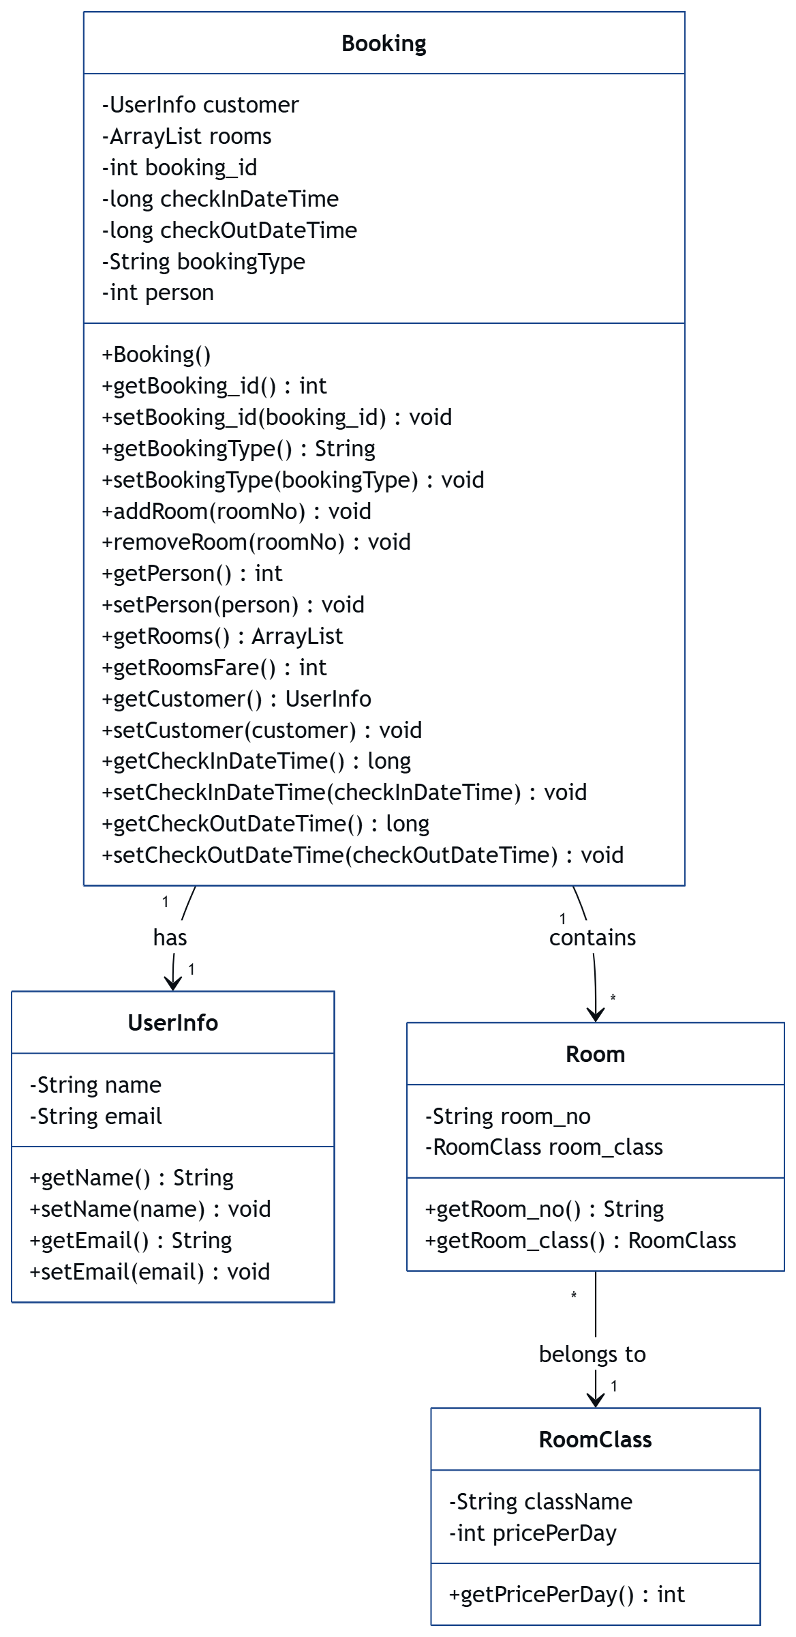Task 1

Task 2
package I3.Classes;

import java.util.ArrayList;

/**
* Represents additional food orders made during a customer's stay.
* Each ExtraOrders object belongs to a customer booking.
*/
public class ExtraOrders {

private ArrayList<Food> foods; // Holds list of Food items
private int orderId;

/**
* Constructor initializes with an empty food list.
*/
public ExtraOrders() {
this.foods = new ArrayList<>();
this.orderId = -1;
}

public ArrayList<Food> getFoods() {
return foods;
}

public void setFoods(ArrayList<Food> foods) {
this.foods = foods;
}

public int getOrderId() {
return orderId;
}

public void setOrderId(int orderId) {
this.orderId = orderId;
}

/**
* Adds a food item to the order.
*/
public void addFood(Food food) {
this.foods.add(food);
}

/**
* Removes a food item by name.
* @param foodName name of food item to remove
*/
public void removeFood(String foodName) {
foods.removeIf(food -> food.getFoodName().equals(foodName)); // Cleaner removal
}

/**
* Calculates total cost of the food order.
*/
public int getTotalCost() {
return foods.stream()
.mapToInt(Food::getPrice)
.sum(); // Stream used for better readability
}
}
package I3.Classes;

/**
* Represents a food item in the system.
* Each food item has a name and a price.
*/
public class Food {

private String foodName; // Name of the food item
private int price; // Price of the food item

/**
* Constructor initializes food item with a name and price.
* @param foodName Name of the food item
* @param price Price of the food item
*/
public Food(String foodName, int price) {
this.foodName = foodName;
this.price = price;
}

public String getFoodName() {
return foodName;
}

public void setFoodName(String foodName) {
this.foodName = foodName;
}
public int getPrice() {
return price;
}
public void setPrice(int price) {
this.price = price;
}
/**
* Returns a string representation of the food item.
* @return Formatted string of food details
*/
@Override
public String toString() {
return "Food{" +
"foodName='" + foodName + '\'' +
", price=" + price +
'}';
}
}

